Lab 9
[Knavtive Serving and Eventing setup]
#Commands for your reference
minikube start --driver=docker --memory=15360 --cpus=8 --base-image=registry.k8s.io/kicbase/stable:v0.0.48 --kubernetes-version=v1.34.0
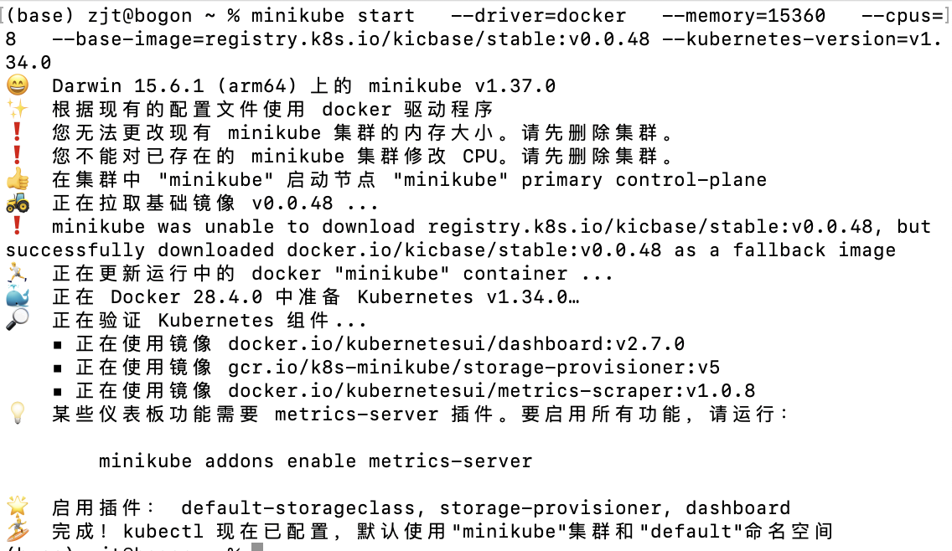
kubectl apply -f serving-crds.yaml
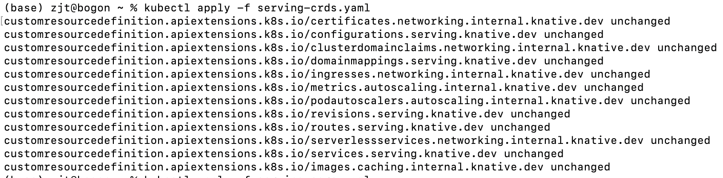
kubectl apply -f serving-core.yaml
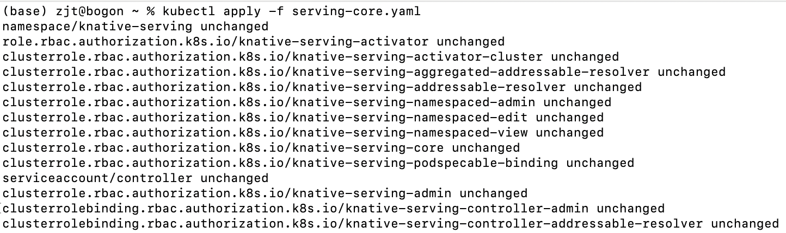
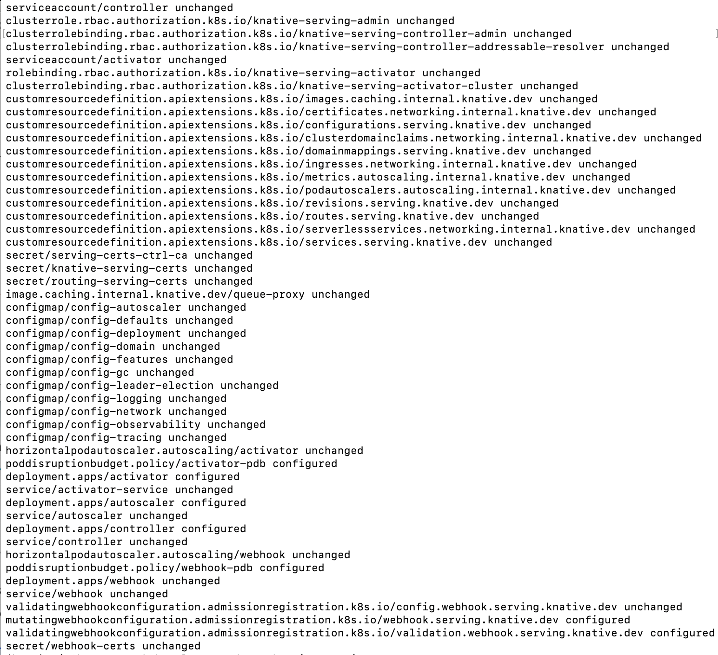
kubectl get pods -n knative-serving
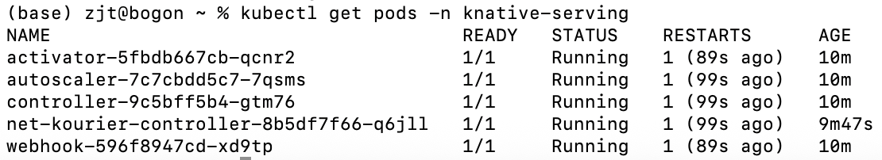
kubectl get pods -A
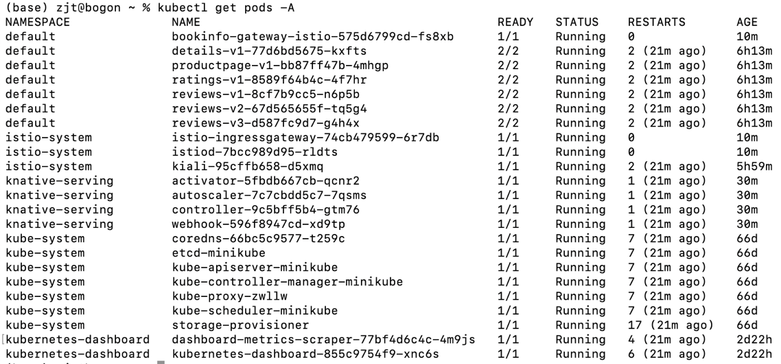
kubectl get pods -n istio-system
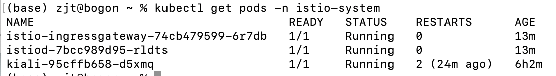
kubectl --namespace istio-system get service istio-ingressgateway
kubectl get pods --namespace cert-manager
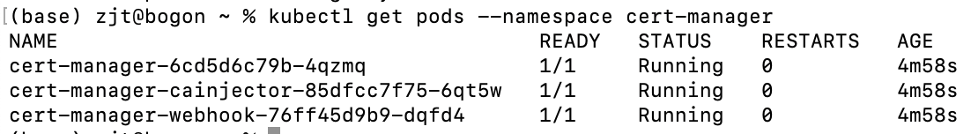
kubectl apply -f eventing.yaml
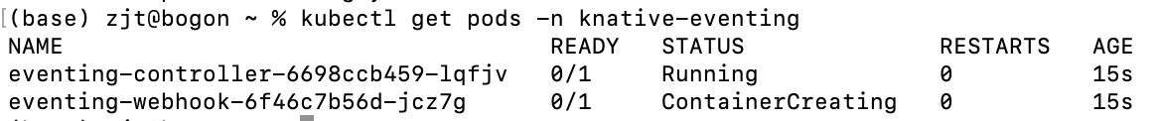

[Knative Functions]
#Commands for your reference
kn func version
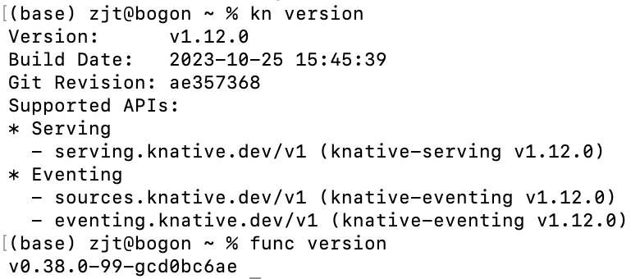
func create -l go hello
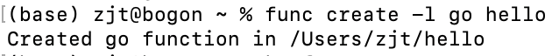
docker run -d -p 5001:5000 --name registry registry:2
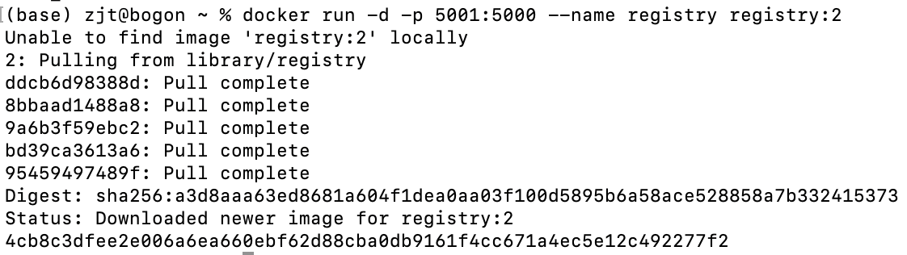
func run --registry localhost:5001
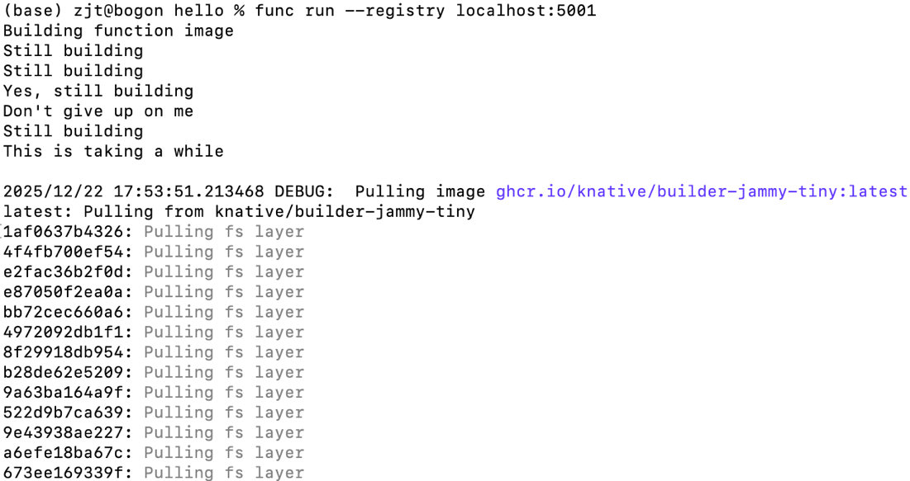
func invoke
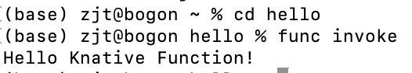
func build --registry locahost:5001
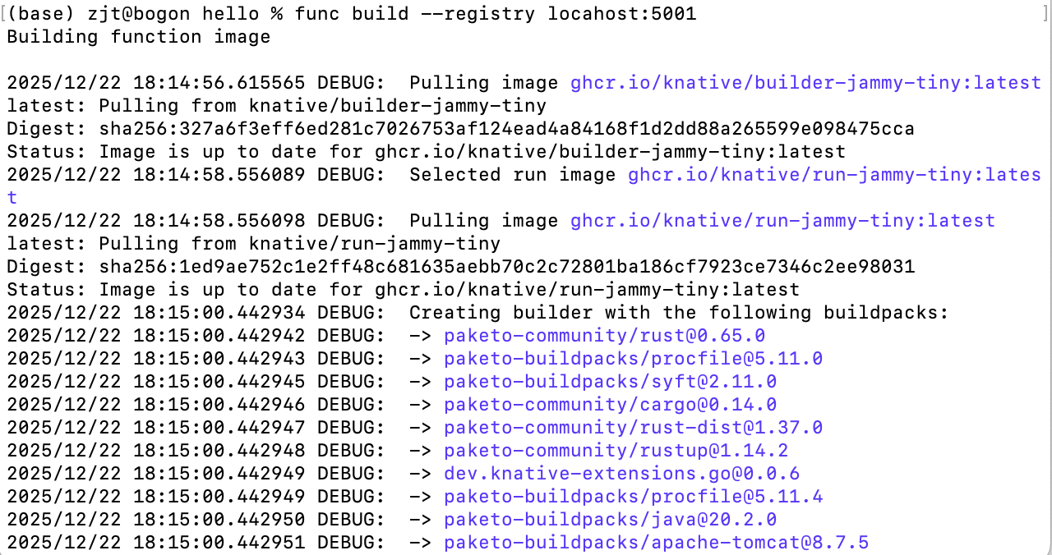
[Knative Serving]
Deploying a Knative service
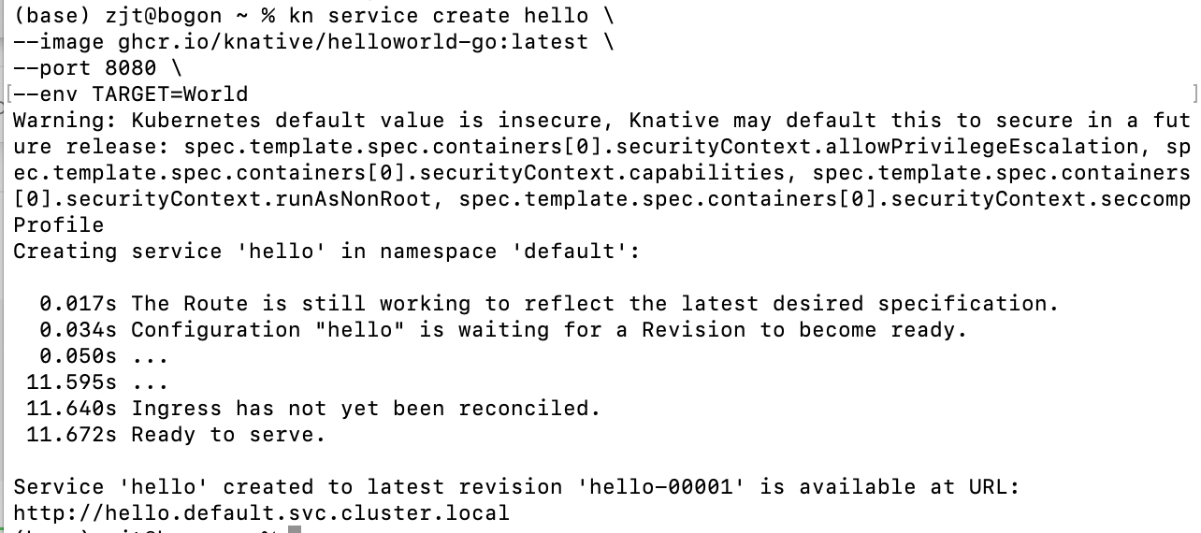
[Knative Eventing]
Knative Eventing provides you with helpful tools that can be used to create event-driven applications, by easily attaching event sources, triggers, and other options to your Knative Services.
Event-driven applications are designed to detect events as they occur, and process these events by using user-defined, event-handling procedures.

